**HUMAN COMPUTER INTERACTION**

**ASSIGNMENT NO. 3**

**Group Assignment**

**SAMPLE SOLUTION**

**BSE 6A,B 04 Marks**

1. Design interview questions and conduct interviews from 2 users per group members to gather user needs regarding chosen prototype application.
2. List down the user needs for the prototype.
3. For the selected prototype, sketch storyboards. Sample is given below for tour guide website.

**SCENERIO #1**

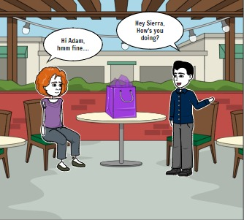 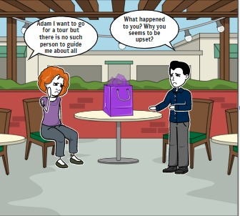

 

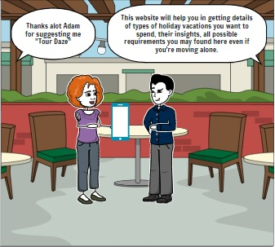 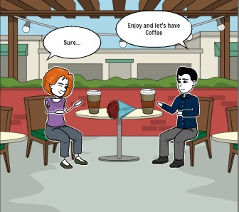

**SCENERIO #2**

 